Kerrie Rogers
Part One
When we think of American sportswear many different brands come to mind - Tommy Hilfiger, J Crew, Gap, Ralph Lauren and Calvin Klein, just to name a few. The main focus of my research included Tommy Hilfiger brand as shown in Macy’s, the J Crew and Gap. The first thing that anyone would notice about these three particular competitors is the difference in shopping experience. The strengths, weaknesses and competitive advantages of these brands are compared in the attached chart (page 3).
My first excursion was to the J Crew store in The Shops at Friendly in Greensboro, North Carolina. J Crew is known for quality and consistency in their apparel. Mannequins displayed in the windows wore the latest trends that were shipped in, and the large wall had a picture of a girl wearing the clothes who looked to be in her mid twenties. The button down woven shirt is one of their signature pieces; they pair it with khaki’s or their latest jeans (see attached chart). I noted that J Crew no longer carries a women’s polo in their line. All of the tables were neatly folded with various shirts, jeans, and accessories.
My second visit was to Gap, located in the adjacent Friendly Center. Gap had a storefront similar to J Crew. Inside the store, the mannequins wore the classic basics: the basic tee, five pocket jean, and khakis. A large wall held mostly jeans in different styles, as listed in the attached chart. Small promotional signs explained the fit of each pair. I noticed that Gap had also updated their iconic items like J Crew; there was not a women’s polo in the store. In its place there were basic Henley’s and detailed embellished t-shirts.
My last stop was the Macy’s department store to view the Tommy Hilfiger line. Department stores have a completely different shopping experience than individual brand stores. Department stores traditionally have departments for every target market; kids, juniors, adults, and professionals, offering a very different shopping experience than brand stores such as Gap and J Crew. The Tommy department lacked the distinctive visual elements to direct the consumer to their product. The Polo, Rugby and Agata Cuff Shirts were hung on racks which did not allow for ease of selection or visual appeal. The five pocket jeans were folded on a table, and the wide legged Khaki’s were hung adjacent to the Tommy shirts, but were very limited in SKU’s.
In the past few years there have been drastic changes in what the “Preppy” style is. Today’s female shoppers are looking for fashion forward clothing that has feminine details. The classic polo and rugby shirts need to be updated to meet today’s consumer demands. Fashion forward preppy style entails purchasing high quality pieces that have small details that make the garments special or unique. For many companies, a new iconic piece, the button down Henley, has replaced the polo shirt. This item is casual yet classic, and is often embellished with details along the front (see chart).
In reinventing the Tommy Hilfiger brand the iconic items could be updated to be more fashion forward. Tommy could update American sportswear by integrating small embellishments on basic items giving them a more fashion forward look. The basic woven button down could be accented by small ruffles overlaying the neckline. The khaki pant could be made into a high rise sailor pant and paired with a micro rugby knit top. Tommy could continue to offer the Polo shirt but add an updated Henley shirt in line with their Gap and J Crew competitors. The Tommy Hilfiger brand can keep its American sportswear roots and still be fashion forward and stay competitive within the market.
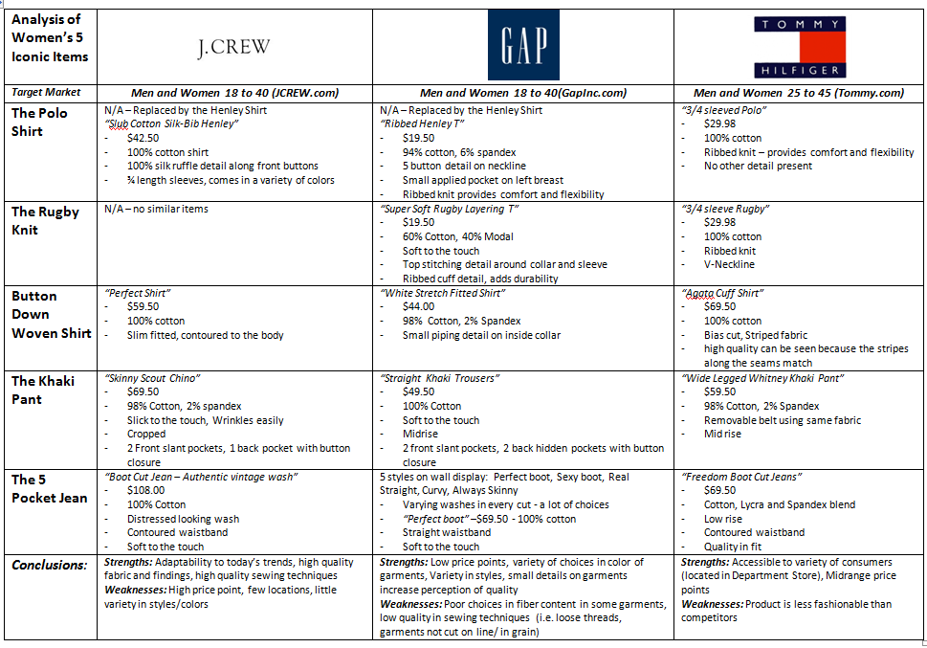
Works Cited
GapInc.com. Gap Inc., 2009. Web. 27 Oct. 2009. <http://www.gapinc.com/public/OurBrands/ brands_gap.shtml>.

JCREW.com. J. Crew, 2009. Web. 21 Oct. 2009. <http://www.jcrew.com/help/about_jcrew.jsp>.

Tommy.com. Tommy Hilfiger, 2009. Web. 26 Oct. 2009. <http://companyinfo.tommy.com/#/ brands_products>.

